**Polyploid cyanobacterial genomes provide a reservoir of mutations allowing rapid evolution of herbicide resistance**   
  
Alberto Scarampi $​^{\text{1}}$, Joshua M. Lawrence $​^{\text{1,2}}$, Paolo Bombelli $​^{\text{1}}$, Darius G. Kosmützky $​^{\text{1}}$, Jenny Z. Zhang $​^{\text{2}}$, Christopher J. Howe $​^{\text{1*}}$ $​^{\text{1}}$ 
  
 Department of Biochemistry, University of Cambridge, UK $​^{\text{2}}$ 
 Yusuf Hamied Department of Chemistry, University of Cambridge, UK $​^{\text{*}}$ 
 Corresponding author: ch26@cam.ac.uk

**Abstract**

Microbial adaptation allows the evolution of a population towards a phenotype that best fits the surrounding environment. As currently understood, adaptive mechanisms in bacteria, which are widely assumed to be haploid or partially diploid, mostly rely on the emergence of spontaneous mutations or lateral gene transfer from a reservoir of pre-existing variants within the surrounding environment, which become established in the population upon exposure to selective pressures. Here, we show that the model freshwater cyanobacterium, *Synechocystis sp.* PCC 6803, which is highly polyploid, can adapt very rapidly to the potent herbicide methyl viologen (MV) and that the variants that are responsible for the adapted phenotypes were already present, at low allelic frequencies, in wild type populations.

We performed several independent adaptive laboratory evolution experiments starting from two phenotypically distinct parent substrains. We isolated 8 MV-adapted strains, showing tolerance to MV concentrations up to 30 times higher than the parent strains. We showed that the resistance persisted after long-term removal of selection pressure and we performed whole genome sequencing on all strains to identify the genetic mutations responsible. Surprisingly, a number of mutations (in genes for membrane transporters) were observed in multiple independently adapted strains and at low frequencies in the parental genomes. This indicates that wild type (highly polyploid) genomes contain a reservoir of mutations that can become rapidly enriched and fixed upon selection by methyl viologen. MV-resistant strains could still perform oxygenic photosynthesis in the presence of MV, unlike wild type strains. However, MV-resistant strains performed oxygenic photosynthesis less efficiently than wild types when MV was absent, suggesting trade-offs in cellular fitness associated with the evolution of MV resistance, and a possible role for balancing selection in the maintenance of the MV-resistance alleles in the absence of MV.

Our results indicate that genome polyploidy can provide a reservoir of conditionally beneficial mutations in some bacteria, facilitating rapid adaptation to stressful conditions. These may include xenobiotics, environmental stresses, and antibiotics.

# Introduction

## The role of genome ploidy for adaptive evolution in bacteria

Bacteria constantly adjust their physiological state to survive in ever changing external conditions. Alterations in cellular activity can be temporary, and mediated by differential genetic and metabolic regulation or more permanent, resulting from the establishment of genetic mutations within bacterial genomes. The latter process, known as adaptative evolution, depends on the availability of beneficial variants and their fixation within the population1. As currently understood, there are multiple way of obtaining beneficial variants, such as through spontaneous mutation, lateral gene transfer between different species or different organisms or through the use of plasmids and phages as vectors for host evolution.2 In general, however, adaptation to new environments occurs in two distinct ways: selection on pre-existing genetic variation (i.e. standing variation) or selection on new mutations (i.e. spontaneous mutagenesis). The former leads to faster evolution, and the fixation of more small-effect and recessive alleles3.

Much of the attention on understanding the mechanisms of microbial adaptation has concentrated on the effect of horizontal gene transfer and the use of monoploid/diploid strains such as *Escherichia coli*. However, axenic cultures of isogenic bacterial populations with no access to environmental reservoirs of beneficial alleles can rapidly evolve adaptive phenotypes4 and, far from the simple textbook description of bacteria as possessing one or two identical copies of their genome, many phylogenetically diverse prokaryotic strains contain multiple non-equivalent copies of their genome5 (i.e. are polyploid). Nonetheless, the physiological role and evolutionary consequences of genome ploidy in bacteria remain largely unknown.

## Cyanobacterial adaptation to oxidative stress

Cyanobacteria are members of the oldest known lineage of oxygenic photosynthetic prokaryotes. The emergence of cyanobacteria is believed to have played a significant role in the subsequent rise of oxygen levels in the Earth’s atmosphere, a geochemical process commonly referred to as the great oxygenation event (GOE). The ecological distribution of cyanobacteria is remarkably diverse, with species thriving in various ecosystems such as terrestrial, freshwater, marine, and even extreme environments, such as Yellowstone hot springs6, Antarctica7 and the Atacama desert7. Cyanobacterial strains display a wide range of morphologies, including unicellular, multicellular, colonial, and filamentous forms. Additionally, they possess unique biochemical characteristics, such as nitrogen fixation, light utilisation, fermentation, and heterotrophy. Considering such diverse habitat distribution and repertoire of metabolic traits, cyanobacteria are arguably the most ecologically successful phylum on Earth8. Additionally, cyanobacteria exhibit a high degree of genome polyploidy, with the model freshwater strain *Synechocystis sp*. PCC 6803 containing more than 100 genome copies during exponential phase9. For these reasons, cyanobacteria are ideal systems to study the role of genome polyploidy in microbial adaptation.

Having first evolved the ability to generate oxygen as a by-product of water oxidation, cyanobacteria must also have been the first organisms having to adapt to oxidative stress (OS)10, the physiological state where excessive production of reactive oxygen species (ROS) overwhelms antioxidant defences and ultimately leads to cellular toxicity. Methyl viologen (MV), a bipyridinium compound known for inducing ROS, is a classic example of a xenobiotic compound employed to study OS. Initially synthesized in 188211, MV’s redox properties were recognized as biochemical tool12 before its potent, broad-spectrum herbicidal capabilities were commercialized13. While its use as an herbicide (known as paraquat) has been banned due to toxicity concerns, MV persists environmentally and continues to be utilized in developing countries14. In addition to agriculture, MV is commonly used as redox mediator in (bio)electrochemical systems15, MV is employed as a robust electron shuttle to reduce a wide range of inorganic and biological electron acceptors. In the presence of molecular oxygen, MV can undergo rapid reoxidation following the single-electron reduction from its divalent (MV2+) to monovalent (MV+) cationic state16. This results in generation of ROS, with superoxide anions being the predominant species. Early experiments on the effects of MV on cyanobacteria indicated that the abrupt killing action of paraquat was due to it being converted into a more powerful inhibitor within the cells17. Subsequent studies confirmed that MV’s cytotoxicity in cyanobacteria is mediated by its ROS-inducing activity and results in the upregulation of antioxidant pathways18–21. Screening of mutants of the model cyanobacterium *Synechocystis* indicated that deletion of redox signalling genes such as the Serine/Threonine kinase spkB and the primary NAD kinase gene, slr1415, results in increased susceptibility to MV22,23. Several studies have further identified strains resistant to MV, where altered transmembrane permeability of MV, rather than modulation of antioxidant pathways, was implicated as the mechanism of resistance24–26. However, this was not true for all of them. For example, a more recent study27 found that a *Synechocystis* mutant lacking cpcG1, encoding the linker protein that connects phycocyanin to the core phycobilisome allophycocyanin, exhibited insensitivity to MV treatment.

## Aims and research questions

In this study, we aimed to understand the mechanisms allowing cyanobacteria to rapidly adapt to oxidative stress induced by methyl viologen. We performed adaptive evolution on two substrains of the model cyanobacterium *Synechocystis sp*. PCC 6803, which enabled to explore different evolutionary path. We isolated several resistant strains, identified the genetic mutations underlying them and observed that the mutations likely responsible for MV resistance were already present, at low frequencies, in wild type parent strains.

# Results

## *Synechocystis* rapidly adapts to MV during photoautotrophic growth

In order to adapt *Synechocystis* toMV, cultures were grown in the standard photoautotrophic medium BG11 until reaching mid-log phase before being exposed to between 0 and 100 uM of MV. As anticipated, we observed growth arrest and bleached phenotypes within 24 hours of MV exposure across a range of concentrations (Fig.1A). Complete growth inhibition was observed at final concentrations as little as 1 uM, confirming the high potency of MV as an antibiotic agent. ROS quantification assays using the fluorogenic substrate DCFH-DA indicated that the wild types *Synechocystis* cultures treated with MV accumulated significantly higher amounts of intracellular ROS compared to non-treated cultures (Supp. Fig 1). The fold change in ROS between MV-treated and untreated cultures was significantly higher under light conditions, confirming that ROS production by MV is dependent on photosynthetic electron transport activity. However, after this expected inhibitory response, cultures treated with 1 μM and 10 μM MV, exhibited a subsequent phase of growth recovery as observed by optical density measurements and the reappearance of a bright green colour within the flask. This was not observed in cultures treated with 100 μM MV. This growth resurgence following MV exposure led to further investigations to elucidate possible mechanisms for this phenomenon.

To discard the possibility of the abiotic degradation of MV as a reason for the observed growth recovery, additional tests were performed. Three independent cultures originating from flasks that had shown signs of adaptation were re-diluted and exposed to 6 μM MV from a freshly prepared stock. These “adapted” cultures remained unresponsive to MV’s growth-inhibitory effects. In contrast, wild type cultures showed the expected growth inhibition effect (SF2). These results demonstrate that the observed growth recovery was not due to abiotic degradation of MV but likely indicative of a biological adaptation mechanism in *Synechocystis*, allowing it to resist MV-induced toxicity.

Additional experiments suggested that MV-adaptation was dependent on the growth phase, with cells exposed to MV in lag and stationary phase not developing MV resistance (SF6). Furthermore, using strains of *Synechocystis* in which the *prqA* gene was deleted and/or later re-complemented, further experiments showed that the presence of the multidrug efflux transporter *prqA* (previously implicated in MV resistance) was not essential for the evolution of MV resistance, as observed by the fact that its deletion or overexpression did not affect the sensitivity to MV nor the adaptation against it (SF7). Finally, we wondered whether the observed adaptability was a result of genetic changes or perhaps due to short-term adaptive mechanisms facilitated by phenotypic plasticity (e.g., upregulation of SOD enzymes or antioxidant pigments passed from mother to daughter cells). We expected that such short-term adaptations would not enable cells to maintain MV-resistance after extended growth in the absence of MV (Fig. 1b). As shown in Fig. 1c-d, when re-exposed to MV after growth in unsupplemented media, all mutants

maintained MV-resistance, suggesting the resistance was caused by genetic mutations

**Figure 1.** **A** Growth curves of *Synechocystis sp.* PCC 6803 strains (“Nixon”) grown in BG11 at 30 C under constant illumination (intensity = 40 uE) in the absence (green trace) and upon addition of various concentrations of methyl viologen during exponential growth (as depicted by the legend on the top left). **B)** Schematic diagram of the experimental procedure to test the effect of selection pressure removal on the persistence of resistance. **C)** Growth curves of WT and resistant strains in the presence and absence of 6uM MV in BG11 at 30 C under constant illumination (intensity = 40 uE) **D)** Growth curves in BG11 + 6 uM MV of resistant strains that were previously (in C) cultivated without (mvR-01) and with (mvR-11) MV at 30 C under constant illumination (intensity = 40 uE). Wild-type strains were used as controls to confirm the toxicity of MV.

## Convergent genetic mutations in methyl viologen resistant strains

To understand whether genomic mutations might underlie the observed long-term adaptation of MV-resistant strains, genomic DNA from several strains that were independently adapted was purified and sequenced.With the aim of maximising the genomic landscape, we adapted and sequenced *Synechocystis* cultures originating from two different parent substrains (“Howe” and “Nixon”) harbouring different genotypes and phenotypes. High-coverage DNA sequencing was performed in order to identify mutations in MV-resistant strains, including any that are present as sub-populations or heterozygoyus alleles. For both wild type and all resistant strains, the aligned reads covered 100% of the reference genome sequences and showed very high coverage (>300). In depth analyses of the genome sequencing results is available in the supplementary information. After having identified mutations that were also present in wild-type strains when compared to various references sequences, such “background” mutations were discarded from the variant analysis results of resistant strains. This led to the identification of resistant-specific mutations. This revealed that overall resistant strains harboured only few mutations, with most strains containing only single mutations with high variant frequencies (>75%). As shown in Fig.2 and Table 1, a shared mutational event observed in three seemingly independent MV-resistant strains (“mvR1_Nixon”, “mvR2_Nixon”, and “mvR3_Nixon”) was a leucine to proline substitution in the sll1180 gene encoding the inner permease of the S-layer type I secretion system. Interestingly, another strain (mvR6) from the same parent labtype harboured another leucine to proline substitutions in the gene sll1181, which is found in the same operon of sll1180 and encodes the translocase of the same *hlyBD* secretion system. An additional shared mutation event was detected in the ABC transporter encoded in the locus slr1174. For this mutational event, 3 strains from the Howe labtype all harboured an arginine to glutamate substitution at residue 115. One strain from the Nixon labtype encoded a mutation in the same arginine residue but substituted to a histidine. This protein and the same arginine residue has been demonstrated to confer resistance to MV in a previous study26 , thereby directly corroborating their findings. An additional shared phenylalanine to cysteine substitution in three strains from the Nixon labtype was observed in the gene slr1609, encoding an AMP-binding protein with predicted acyl-CoA synthetase activity. Additional unique mutations were detected in a NAD(P)H dehydrogenase subunit, as shown in Table 1. Interestingly, MV-resistant strains only encoded between one to a maximum of 3 (for mvR6_Nixon) non-synonymous mutations with variant frequency greater than 75%. One outlier was mvR09_Howe, which showed none non-synonymous mutations greater than the frequency threshold. All strains encoded additional synonymous mutations and in genomic regions outside annotated coding sequences as listed in the SI. Leveraging the high coverage obtained by our deep sequencing experiments, we calculated the frequency of each base among the reads at the locations of the mutations in the corresponding wild-type strains. As observed in Table 1, we observed a clear parent-dependent enrichment of variants corresponding to the shared mutational events. For example, for the mutation in the sll1180 gene, we detected a polymorphic site where 10.4% of the reads from the Nixon wild type strain showed the same base that was mutated in the three Nixon MV-resistant strains. On the other hand, 100% of the reads from the Howe wild type at the same location were equal to the reference base. The same is true for the other shared mutational events in slr1174 and slr1609. This indicates that the shared mutations observed in MV-resistant strains were already present at low frequencies in the wild-type populations and became enriched 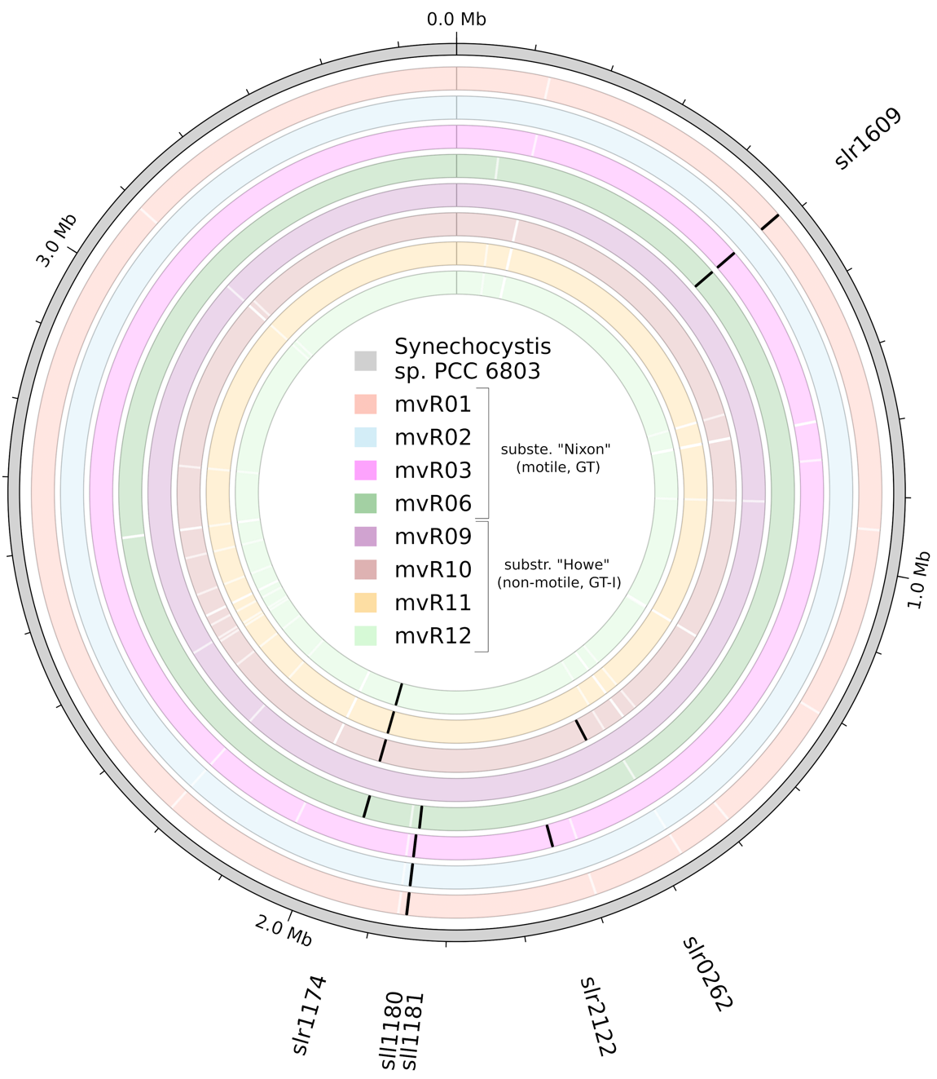following MV treatment.

**Figure 2.** Comparative genomic analysis of multiple MV-R strains. Circular representation of genomes with concentric circles corresponding to different strains. White ticks denote single nucleotide polymorphisms (SNPs) across both coding and non-coding sequences, while black lines indicate non-synonymous mutations within coding sequences (CDSs). All depicted muta- tions have been filtered to exclude those present in respective background strains

|  |  |  |  |  |  |
| --- | --- | --- | --- | --- | --- |
| **Locus** | Strains | Description | Variant % | Variant % in WT | Mutation |
| sll1180 | mvR01_Nixon, mvR02_Nixon, mvR03_Nixon | peptidase domain-containing ABC transporter HlyB | 100%, 99.80%, 100.00% | Howe: 0% Nixon:10.4% | L139P |
| sll1181 | mvR06_Nixon | ABC family efflux transporter periplasmic adaptor subunit (HlyD) | 83.10% | Howe: 0% Nixon:0% | L115P |
| slr1174 | mvR10_Howe, mvR11_Howe, mvR12_Howe | ABC-2 family transporter protein | 100%, 100.00%, 100.00% | Howe: 6.7% Nixon:0% | R115G |
| slr1174 | mvR06_Nixon | ABC-2 family transporter protein | 81.20% | Howe: 0% Nixon:0.% | R115H |
| slr1609 | mvR01_ Nixon, mvR03_Nixon, mvR06_Nixon | long-chain acyl-CoA synthetase | 99.6%, 100.00%, 100.00% | Howe: 0% Nixon:4.2% | F255C |
| slr0262 | mvR10_Howe | NAD(P)H dehydrogenase subunit | 84.80% | Howe: 0% Nixon:0% | A99P |

**Table 1.** Table of non-synonymous mutations resulting from comparative genomic variant anal- ysis of MV resistant strains.

## Evolution of resistance is associated with trade-offs in cellular fitness

After having characterised the genotype of the isolated MV-resistant strains we performed growth curves and oxygen quantification experiments to assess the impact of the observed mutations on the physiology of the cells. As shown in Fig.3(a-c), resistant strains grew similarly to wild types in the absence of MV at low light intensities. However wild type strains grew significantly faster than resistant when the light intensity was increased to 150 µmol·s-1·m-2. As expected, in the presence of MV, wild type strains died under both illumination regimes whereas resistant strains survived the treatment and displayed slightly different growth rates between each others.

Given the central role of oxygenic photosynthesis on cyanobacterial fitness and the role of MV in oxygen scavenging, we performed oxygen electrode measurements on all sequenced wild-type and MV-resistant strains to determine the rates of oxygen evolution as a function of applied light intensity. Expectedly, as shown in Fig.3g, MV treatment resulted in significantly reduced oxygenic photosynthetic activity in wild type strains (ca. 7.6-fold and 8.8-fold reduction in “Nixon” and “Howe” strains respectively). On the contrary, unaffected rates of oxygen evolution observed in resistant strains indicated the mutants could perform oxygenic photosynthesis even in the presence of methyl viologen (Fig.3f). When resistant strains were grown in the absence of MV, they showed significantly reduced rates of oxygen evolution (Fig.3e), especially at high light intensities, similarly to the reduced growth rates displayed by resistant strains when grown at higher light intensities (Fig.3c) This indicates that evolution of resistance presents a cost in cellular fitness and explain why the conditionally beneficial mutations present at low 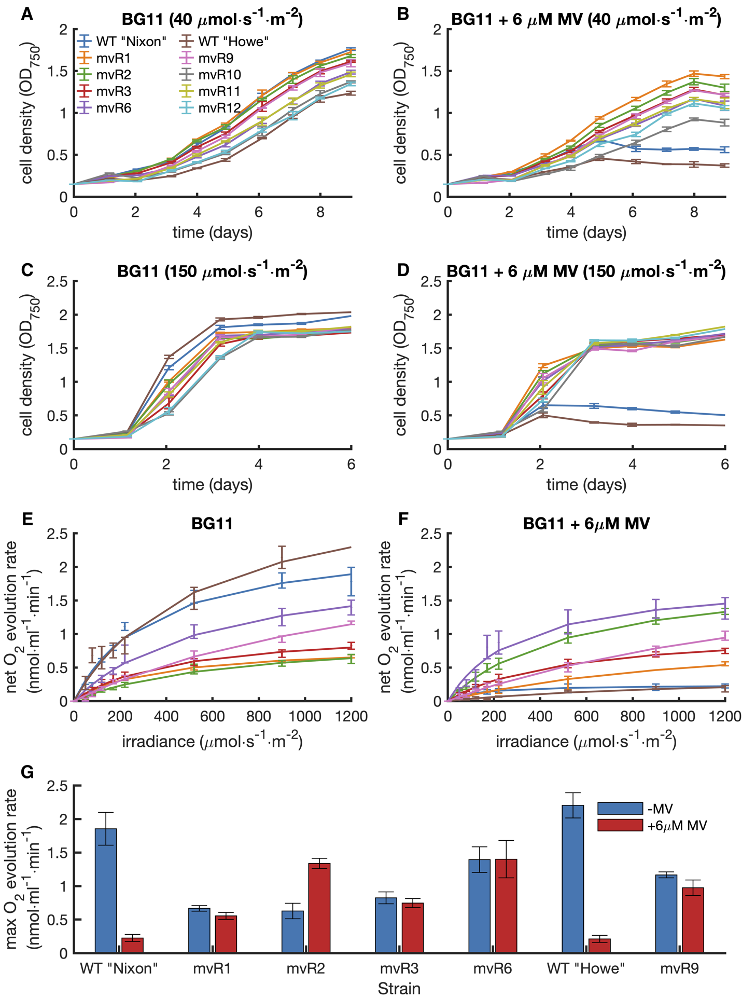frequency have not fixed in wild-type populations.

## Electrochemical evidence for altered MV transport in resistant strains

Genomic analyses indicated that mutant strains had mostly mutations in membrane transport components and oxygen electrode experiments demonstrated that the toxic effect of MV, which stems from its intracellular interaction with PSI, was bypassed in mutant strains. However, the findings presented so far did not explain the effects of the observed mutations and the mechanisms by which MV’s toxicity is bypassed. Leveraging MV’s membrane permeability and redox activity, we conducted a series of electrochemical experiments to characterise the extracellular electron transfer activities of both wild-type and MV-resistant strains in the presence and absence of MV. As depicted in Figure 4, when MV was absent from the electrolyte chamber (A,C), both wild-type and mutant strains produced photocurrents of similar amplitudes and profiles. This implies that the emergence of methyl viologen resistance does not influence the cell’s electrogenic activity in the absence of MV. However, upon addition of 6 μM MV into the anodic chamber, the electrogenic profiles from the wild-type (B) and MV-adapted strains (D) displayed significant differences. During the initial three light cycles, wild-type strains generated large photocurrents, reaching amplitudes nearly three times greater than those observed without the presence of MV. Subsequently, the electrogenic activity decreased, and the photocurrent profiles were no longer detectable. By the experiment’s end, the formerly green biofilm of cells adhered to the electrode turned white, suggesting cell toxicity. Conversely, the MV-adapted strains, when subjected to MV, produced photocurrents similar to those recorded in the absence of MV. Unlike the wild-type cells exposed to MV, the biofilms derived from the MV-adapted strains remained green and viable until the conclusion of the experiment. culture’s supernatant.

To quantify the concentration of MV in the culture supernatant, and thus deduce its intracellular accumulation, we then employed cyclic voltammetry (CV). Cultures of wild types and resistant strains were treated with MV and grown photoautotrophically. After 4 and 15 hours post treatment, the cells were centrifuged and the concentration of extracellular MV was quantified by performing CVs on the supernatant. At a potential of ca. -0.5 V vs Ag/AgCl, MV reduces molecular oxygen, so we performed CVs with and without nitrogen purging to use the oxygen reduction peak as an estimate of MV2+concentration. As shown in Fig.4(e-n), the CVs showed that indeed the supernatant from all cultures showed characteristic MV redox peaks, indicating that MV has not been degraded. As observed by the reduction in the peaks in the presence of oxygen at 4 and 15 hours, the concentration of MV2+ in the supernatant from wild-type cultures decreased over time. This indicates that in these cultures MV2+ is reduced into its membrane permeable form, goes intracellularly and thus MV2+ in the supernatant disappears. On the contrary, the oxygen reduction peaks catalysed by MV2+ in the supernatant from all resistant cultures remained almost unchanged. This condfirms that resistant strains display a reduced intracellular accumulation of MV.

# 

# Discussion

In this study, we demonstrated that multiple substrains of the model freshwater cyanobacterium *Synechocystis* could spontaneously and rapidly evolve resistance to the bactericidal effects of methyl viologen. Despite wild type cultures bleached after treatment with MV at concentrations as low as 1 μM, emergence of viable cultures was observed during liquid cultivation after a period of apparent growth inhibition. These adapted cultures were insensitive to addition of freshly prepared MV, indicating that such growth resurgence was a result of biological evolution rather than chemical degradation, as often observed in the case of β-lactam antibiotics28. Emergence of spontaneous mutants was observed for both motile (“Howe”) and non-motile (“Nixon”) *Synechocystis* substrains, but only occurred when MV was added during mid-log growth and at concentrations lower than 100 μMNot only we recapitulated the same mutations observed by Prosecka et al., (2009), but we expand on their knowledge by identifying the conditions in which such adaptive evolution can occur in liquid cultures during photoautotrophic cultivation. This can be advantageous for screening cyanobacterial strains robust to oxidative stress in Adaptive Laboratory Evolution (ALE) experiments using liquid-based continuous cultivation systems and industrial photobioreactors, as demonstrated by similar efforts aimed at enhancing photosynthesis 29.

Given that MV treatment can significantly alter gene expression profiles, antioxidant responses and the secretome of cyanobacteria30, we wondered whether the observed adaptation to MV was consistent with a genetic or an epigenetic inheritance mode of resistance4. As revealed by the persistence of resistance following long-term cultivation in the absence of selective pressure, our results suggests that resistance is accompanied by changes in the DNA sequence of cyanobacterial genomes. Genomic sequencing experiments and analyses further corroborated this by identifying a few mutations specific to MV-adapted strains. Although there is no single mechanism to obtain antimicrobial resistance, generally this is achieved via reduction in intracellular drug accumulation (reduced permeability and antibiotic efflux), modification or alteration of the bacterial antibiotic target, modification or destruction of the drug itself, and bypass of whole metabolic pathways 31. Our sequencing results indicated that all resistant strains, with the exception of one (mvR_09) encoded non-synonymous mutations in membrane transporter components. Corroborating previous studies 25,32, our findings suggest that the mode of MV resistance in *Synechocystis* is via reduction in intracellular drug accumulation. For the first time, we sequenced whole genomes and identify variants in multiple independently adapted strains from two genotypically and phenotypically distinct parent substrains. All mutants apart from mvR_09 encoded mutations in either the type I S-layer secretion system or the ABC transporter slr1174. Interestingly, previous studies26 isolated MV-resistant strains with mutations in the same conserved R115 residue of slr1174 as we observed for strains mvR6,10,11,12, thereby directly hinting at slr1174 role in MV resistance. By performing site-directed mutagenesis they confirmed the importance of this residue in conferring resistance to MV and suggested that changes in this residue determine the substrate specificity of the transporter. Four other mutants encoded single nucleotide polymorphisms in the sll1180-sll1181 operon, which encodes the type I system that secretes the S-layer protein and has been implicated in antibiotic and acid stress tolerance. Additionally, three strains from the motile and glucose-tolerant “Nixon” labtype encoded a mutation in the slr1609 gene, encoding a long-chain acyl-CoA synthetase. Given that ROS can cause damage to lipids via peroxidation reactions, such mutation might further help the cells to cope with MV-induced toxicity. Unlike we did not find mutations in the MATE-type efflux transporters PrqA, which was previously implicated in controlling MV resistance in *Synechocystis*. In addition, adaptive evolution experiments using *Synechocystis* strains that lacked or overexpressed the *prqA* gene (Supp.Fig.7), indicated that this gene, although might be important for susceptibility to sublethal MV concentrations, is not essential for the long-term evolution of MV resistance.

At first, we were surprised to observe such a high frequency of shared mutational event in seemingly independently evolved strains. Given that adaptive evolution was performed in different flasks (which remained always sealed post MV treatment) inoculated from different colonies and subjected to independent MV treatments, it is unlikely that such shared mutational events were a result of cross-contamination. A principal component analysis (Supp.Fig.12) which considered all mutations (also in non-coding regions and non-synonymous) indeed discarded this possibility. In fact, strains that harboured the shared mutational events differed significantly between each other when all mutations were considered and therefore are likely to be different substrains that obtained the same mutations by convergent evolution. The alternative explanation is that those mutations that converged in some substrains and not others were already present at low frequency in wild type strains and were enriched in MV-resistant strains by natural selection following MV treatment. This argument is favoured also by the fact that we detected the same mutations as those observed following ALE to enhance acid stress and similar spontaneous MV-resistant mutants by 33,34 . The variant frequency analysis performed in wild type strains (Table1) and Sanger sequencing chromatograms (add fig X) indeed confirmed that the beneficial mutations observed in MV resistant mutants were also present at low frequencies in wild type, unadapted cultures. Given that genome sequencing and colony PCRs were performed on isolated, clonal colonies, this suggests that there are polymorphic sites in the genome of individual cells. Genome polyploidy could allow for a larger genetic “playground,” wherein certain gene copies can undergo mutations without drastically compromising overall cellular function. This redundancy may have been evolutionarily favoured, especially in changing environments where adaptability is crucial. Here for the first time we present evidence that such genomic polymorphism in clonal populations of cyanobacteria might have a biological function in enabling balancing selection mechanisms to adapt to changing environments. Further experiments using single cell genome sequencing and RNA-seq will be useful to further corroborate this mechanism.

After having identified that genetic mutations underlying MV resistant strains, characterisation experiments were performed to assess the trade-offs which often accompany the evolution of antibiotic resistance. All isolated MV-resistant strains showed reduced rates of oxygen evolution compared to wild types in the absence of MV. This suggests a negative impact of MV resistance on the fitness of cyanobacterial cells and explains why the observed, conditionally beneficial mutations have not fixed in wild type populations. We further employed electrochemical techniques to probe the effect of MV evolution on the extracellular electron transfer of cyanobacteria and to quantify MV’s transport across the cell.

As shown by chronoamperometries in the presence of MV, MV dramatically increased the photocurrent, confirming its role in accepting intracellular photosynthetic electrons to reduce extracellular electrodes. However, such large photocurrent were short lived and the biofilms adhered to the electrodes were bleached, suggesting that extracting electrons from PSI with MV inevitably leads to ROS production and cell death. On the contrary with the exception of strains mvR1-2-3 (see Supp.Fig.5), MV-resistant strains in the presence of MV displayed similar photocurrents than those observed in its absence and remained viable at the end of the experiment. This indicates that MV-resistant strains of *Synechocystis* achieve resistance primarily by abolishing intracellular accumulation of MV or by inhibiting its redox activity (e.g. by chemical degradation). Cyclic voltammetries performed on the supernatant of cultures after 4 or 15 hours post MV treatment indicated that the extracellular concentration of MV in MV-resistant cultures remains unchanged over time, whereas it declines (as MV penetrates intracellularly) in wild types. This finding provides direct evidence that is the reduction of intracellular MV accumulation the mode of resistance, corroborating the genomic observation, This is a double-edged sword. On one hand, these strains can survive in MV-rich environments, which is advantageous for their ecological competitiveness and potential biotechnological applications. On the other hand, the very mechanism that confers resistance— the prevention of intracellular MV accumulation—negates the utility of MV as a redox mediator for these strains. In essence, if MV cannot accumulate intracellularly, it cannot serve its role in shuttling electrons from intracellular metabolic pathways to the electrode. This means that while MV-resistant strains can survive in environments where MV is present, they cannot benefit from the enhancement of photocurrents that MV typically offers.

The MV-resistant strains isolated in this study might be useful for future biotechnological applications. For example, MV-resistant strains could be used in co-culture based bioelectrochemical devices in which cyanobacteria provide sugars to electroactive heterotrophic bacteria in the same chamber, where MV could be added as a redox mediator to enhance the performance without compromising the photosynthetic activity of the primary producers. In addition, MV can be employed as an electron mediator to supply external electrons for the turnover of intracellular nitrogenase in bioelectrochemical devices containing *Synechococcus elongatus* PCC 7942 for bioelectrochemical nitrogen fixation. However, MV toxicity was reported as a limiting factor and, based on these findings exposure to MV will inevitably lead to reduction of intracellular MV and thus MV-mediated nitrogenase turnover after long-term operation of such devices. Expression of MV-resistant genes like the mutated slr1174 protein driven under a promoter specific to photosynthetically active cells and not within heterocysts could allow to introduce MV in cultures of filamentous diazotrophic cyanobacteria. The cells could still perform photosynthesis being resistant to MV, but MV could shuttle into heterocysts cells, which are anaerobic, to significantly enhance biological nitrogen. Future work should also determine whether enhanced efflux of methyl viologen as displayed by the strains isolated here, also leads to enhanced efflux of additional compounds in a generalised way. If so, this approach would be beneficial to enhance the secretion of target compounds for photobioproduction.

# Methods

## Strains and Growth Conditions

During this study two labtypes of the model cyanobacterium *Synechocystis* sp. PCC 6803 were used. The “Howe” labtype is a non-motile and glucose tolerant derivative of the GT-Kazusa strain that was maintained in the laboratory of Professor. Christopher J. Howe (University of Cambridge, UK). The “Nixon” type is a glucose tolerant and motile substrain that was originally a kind gift from the laboratory of Peter J. Nixon at (Imperial College London, U.K.). Cryopreserved stocks of both cultures were streaked onto BG11 Petri dishes containing 1.5% of agar. Single colonies appeared after approximately 14 days following incubation at 30C under white light illumination (100 uE). For growth curve experiments showing spontaneous evolution of MV resistance, individual colonies from the same plate were inoculated into 40 mL of BG11 medium into 50 mL Nunc flasks. Cell growth was monitored by quantifying the optical density at 750 nm using a UV-Vis Spectrophotometer (Shimadzu) using BG11 as a blank. To prevent cross-contamination, measurements were taken directly from the flask instead of a cuvette, allowing to maintain sterility throughout the whole period of the growth curve. MV stock solution were prepared by dissolving methyl viologen dichloride hydrate powder (Sigma) into autoclaved deionised water at a stock concentration of 6 mM. The solution was filter-sterilised using a 0.22 um filter and stored at -20C. For the growth curve in Figure 1 where different concentrations of MV were added into cultures, 1000x stock solution for each tested working concentrations were prepared in order to add the same volume of liquid in all conditions. The same volume of sterilised water was added for negative control conditions containing no methyl viologen. After resistant cultures appeared following MV treatment, these were spotted on BG11 plates (without MV) to isolate individual colonies, which were then inoculated in BG11 (no MV) prior to genome sequences. Parallelly, they were also inoculated on BG11 + 6 uM MV and spotted on MV containing plates to confirm that the resistance was maintained following growth in the absence of MV.

## Genome Sequencing and Analysis

For genome purification, *Synechocystis* cultures inoculated from single colonies were grown photoautotrophically (40 uE) until an OD750 of 1, and then harvested at 5000 rpm for 5 minutes. The volume of culture to pellet was calculated to obtain a total chlorophyll A mass of 40 ug, calculated according to the equation: [chlA] (mg/ml)=(OD680-OD750)x10.854 35. The supernatant was then discarded, and the pellet was resuspended in 170 μL of freshly prepared Smoker B buffer, containing 50 mM Tris/Cl (pH 8), 50 mM EDTA, 1 % (v/v) Triton, X-100, 20 mg/mL lysozyme and 30 μL RNase ([stock]=12 mg/mL). This pre-lysis mixture was incubated at 37◦C for 1 hour. Following this, the tubes were vigorously vortexed and 20 μL of Proteinase K ([stock]= 20 mg/mL) was introduced to the solution. Another round of incubation was then carried out at 56◦C for one hour. To further homogenize the sample, glass beads were added to the solution, which was then subjected to bead beating for 5 cycles of 1 min each. In between each cycle, the tubes were cooled down on ice for 1 min. After bead beating, the mixture was centrifuged at 5000 rpm for 5 minutes. This supernatant was then carefully transferred to a NucleoSpin Tissue silica column and purification was performed according to the manufacturer instruction (Macherey-Nagel). The gDNA was then eluted by adding 50 μL of pre-equilibrated (70◦C) EDTA-free elution buffer to the column, allowing it to sit for 3 minutes, and then centrifuging at 11000 rpm for 1 minute. A subsequent addition of 50 μL of elution buffer was performed, followed by a 3-minute waiting period, and a final spin down to collect highly pure and concentrated gDNA. The concentration of purified gDNA was quantified using a nanodrop and its integrity assessed by gel electrophoresis. Library preparation and genome sequencing was performed by Novogene (UK) using Illumina PE150 technology. Results from genome extraction and QC reports are available in the supplementary information. The resulting raw reads were paired and trimmed using BBDuk and aligned to various reference genomes using bowtie2. Variant analysis was performed in Geneious and mutations were filtered and analysed using custom python scripts (scripts and all datasets available in SI).

Photosynthetic oxygen evolution rates and respiration rates were determined on 2 mL cell cultures at a concentration of 4 nmol chlorophyll mL−1 harvested at an OD750 of 0.5 using a Clark-type oxygen electrode system (Oxyview, Hansatech) maintained at 30°C. Following dark adaptation (30 min), oxygen-exchange rates were recorded for 15 min at increasing light intensities (10, 25, 60, 150, 350, 900, and 2,000 µmol photons m−2 s−1) using two 9W white LED bars (RS components, 786-8979). Each light period was followed immediately by 15 min in darkness to calculate the respiration rates. The respiration rate following illumination at each light intensity was subtracted to estimate the net rate of photosynthetic oxygen evolution, accounting for oxygen uptake under illumination. To quantify the electrogenic activities of the strains, chronoamperometric measurements were undertaken at an oxidative electrode bias potential of 0.3 V vs Ag/AgCl reference electrodes (BASI) using a MultiEmStat4 potentiostat. These measurements were conducted on custom made flat photoelectrochemical cells containing indium tin oxide (ITO)-coated PET electrodes, open air platinum-coated carbon cloth cathodes, under alternating light (100 uE) and dark periods lasting two hours each. For each experiment, cultures containing a total of 250 nmoles of chlA were pelleted, washed, and loaded on the flat ITO electrodes. Cyclic voltammetries were performed using a three-electrode electrochemical cell containing a glassy carbon working electrode, platinum mesh counter and Ag/AgCl reference electrode. Scans were performed at 50 mV/s using 5 mL of supernatant obtained after centrifugation of cultures at 5000 rpm for 5 min. For anoxic scans, the solution was bubbled with nitrogen gas using a gas line tube connected to a syringe, which was bubbled for 10 min before the scan and placed in the air interface to prevent noise during the measurement.

**References**

1. Garoña, A., Santer, M., Hülter, N. F., Uecker, H. & Dagan, T. Segregational drift hinders the evolution of antibiotic resistance on polyploid replicons. *PLoS Genet* **19**, (2023).

2. Shi, A., Fan, F. & Broach, J. R. Microbial adaptive evolution. *J Ind Microbiol Biotechnol* **49**, 76 (2022).

3. Barrett, R. D. H. & Schluter, D. Adaptation from standing genetic variation. *Trends Ecol Evol* **23**, 38–44 (2008).

4. Adam, M., Murali, B., Glenn, N. O. & Potter, S. S. Epigenetic inheritance based evolution of antibiotic resistance in bacteria. *BMC Evol Biol* **8**, (2008).

5. Soppa, J. Non-equivalent genomes in polyploid prokaryotes. *Nature Microbiology* vol. 7 186–188 Preprint at https://doi.org/10.1038/s41564-021-01034-3 (2022).

6. Miller, S. R. & Castenholz, R. W. Evolution of thermotolerance in hot spring cyanobacteria of the genus Synechococcus. *Appl Environ Microbiol* **66**, 4222–4229 (2000).

7. Lumian, J. *et al.* Biogeographic distribution of five Antarctic cyanobacteria using large-scale k-mer searching with sourmash branchwater. *Front Microbiol* **15**, 1328083 (2024).

8. Peschek, G. A., Bernroitner, M., Sari, S., Pairer, M. & Obinger, C. Life Implies Work: A Holistic Account of Our Microbial Biosphere Focussing on the Bioenergetic Processes of Cyanobacteria, the Ecologically Most Successful Organisms on Our Earth. *Bioenergetic Processes of Cyanobacteria* 3–70 (2011) doi:10.1007/978-94-007-0388-9_1.

9. Griese, M., Lange, C. & Soppa, J. Ploidy in cyanobacteria. *FEMS Microbiol Lett* **323**, 124–131 (2011).

10. Latifi, A., Ruiz, M. & Zhang, C. C. Oxidative stress in cyanobacteria. *FEMS Microbiology Reviews* vol. 33 258–278 Preprint at https://doi.org/10.1111/j.1574-6976.2008.00134.x (2009).

11. Weidel H & Russo M. Studien über das Pyridin [Studies of pyridine]. *Monatshefte für Chemie (in German)* **3**, 850–885 (1882).

12. Michaelis, L. & Hill, E. S. THE VIOLOGEN INDICATORS. *J Gen Physiol* **16**, 859–873 (1933).

13. Brian, R. C., Homer, R. F., Stubbs, J. & Jones, R. L. *A NEW HERBICIDE 1’-ETHYLENE-2 : 2’-DIPYRIDYLIUM DIBROMIDE*. *NATURE February* vol. 15 (1958).

14. Hance, R. J., Byast, T. H. & Smith, P. D. Apparent decomposition of paraquat in soil. *Soil Biol Biochem* **12**, 447–448 (1980).

15. Gemünde, A., Lai, B., Pause, L., Krömer, J. & Holtmann, D. Redox Mediators in Microbial Electrochemical Systems. *ChemElectroChem* vol. 9 Preprint at https://doi.org/10.1002/celc.202200216 (2022).

16. Sétif, P. Electron-transfer kinetics in cyanobacterial cells: Methyl viologen is a poor inhibitor of linear electron flow. *Biochimica et Biophysica Acta (BBA) - Bioenergetics* **1847**, 212–222 (2015).

17. Vaishampayan, A. Strong mutagenic action of a bipyridylium herbicide in a N2-fixing blue-green alga. *Experientia* **40**, 1016–1019 (1984).

18. Thomas, D. J., Avenson, T. J., Thomas, J. B. & Herbert, S. K. A Cyanobacterium Lacking Iron Superoxide Dismutase Is  Sensitized to Oxidative Stress Induced with Methyl Viologen but Is  Not Sensitized to Oxidative Stress Induced with  Norflurazon. *Plant Physiol* **116**, 1593 (1998).

19. Campbell, W. S. & Laudenbach, D. E. Characterization of four superoxide dismutase genes from a filamentous cyanobacterium. *J Bacteriol* **177**, 964–972 (1995).

20. Li, T. *et al.* Differential expression and localization of Mn and Fe superoxide dismutases in the heterocystous cyanobacterium Anabaena sp. Strain PCC 7120. *J Bacteriol* **184**, 5096–5103 (2002).

21. Kim, J. H. & Suh, K. H. Light-dependent expression of superoxide dismutase from cyanobacterium Synechocystis sp. strain PCC 6803. *Arch Microbiol* **183**, 218–223 (2005).

22. Mata-Cabana, A., García-Domínguez, M., Florencio, F. J. & Lindahl, M. Thiol-Based Redox Modulation of a Cyanobacterial Eukaryotic-Type Serine/Threonine Kinase Required for Oxidative Stress Tolerance. *https://home.liebertpub.com/ars* **17**, 521–533 (2012).

23. Gao, H. & Xu, dong. The cyanobacterial NAD kinase gene sll1415 is required for photoheterotrophic growth and cellular redox homeostasis in Synechocystis sp. strain PCC 6803. *J Bacteriol* **194**, 218–224 (2012).

24. Babykin, M. M. *et al.* On the involvement of the regulatory gene prqR in the development of resistance to methyl viologen in cyanobacterium Synechocystis sp. PCC 6803. *Russ J Genet* **39**, 18–24 (2003).

25. Nefedova, L. N., Fantin, Y. S., Zinchenko, V. V. & Babykin, M. M. The prqA and mvrA Genes Encoding Drug Efflux Proteins Control Resistance to Methyl Viologen in the Cyanobacterium Synechocystis sp. PCC 6803. *Russ J Genet* **39**, 264–268 (2003).

26. Prosecka, J. *et al.* A novel ATP-binding cassette transporter is responsible for resistance to viologen herbicides in the cyanobacterium Synechocystis sp. PCC 6803. *FEBS Journal* **276**, 4001–4011 (2009).

27. Oh, S. & Montgomery, B. L. Roles of CpcF and CpcG1 in Peroxiredoxin-Mediated Oxidative Stress Responses and Cellular Fitness in the Cyanobacterium Synechocystis sp. PCC 6803. *Front Microbiol* **10**, (2019).

28. Brouwers, R. *et al.* Stability of β-lactam antibiotics in bacterial growth media. *PLoS One* **15**, (2020).

29. Dann, M. *et al.* Enhancing photosynthesis at high light levels by adaptive laboratory evolution. *Nat Plants* **7**, 681–695 (2021).

30. Sukkasam, N., Leksingto, J., Incharoensakdi, A. & Monshupanee, T. Chemical Triggering Cyanobacterial Glycogen Accumulation: Methyl Viologen Treatment Increases Synechocystis sp. PCC 6803 Glycogen Storage by Enhancing Levels of Gene Transcript and Substrates in Glycogen Synthesis. *Plant Cell Physiol* **63**, 2027–2041 (2023).

31. Darby, E. M. *et al.* Molecular mechanisms of antibiotic resistance revisited. *Nature Reviews Microbiology 2022 21:5* **21**, 280–295 (2022).

32. Ongley, S. E., Pengelly, J. J. L. & Neilan, B. A. A multidrug efflux response to methyl viologen and acriflavine toxicity in the cyanobacterium Synechocystis sp. PCC6803. *J Appl Phycol* **28**, 2793–2803 (2016).

33. Uchiyama, J. *et al.* Genomic analysis of parallel-evolved cyanobacterium Synechocystis sp. PCC 6803 under acid stress. *Photosynth Res* **125**, 243–254 (2015).

34. Uchiyama, J. *et al.* Characterization of ABC transporter genes, sll1180, sll1181, and slr1270, involved in acid stress tolerance of Synechocystis sp. PCC 6803. *Photosynth Res* **139**, 325–335 (2019).

35. Lea-Smith, D. J. *et al.* Thylakoid terminal oxidases are essential for the cyanobacterium Synechocystis sp. PCC 6803 to survive rapidly changing light intensities. *Plant Physiol* **162**, 484–495 (2013).